Parkman Church
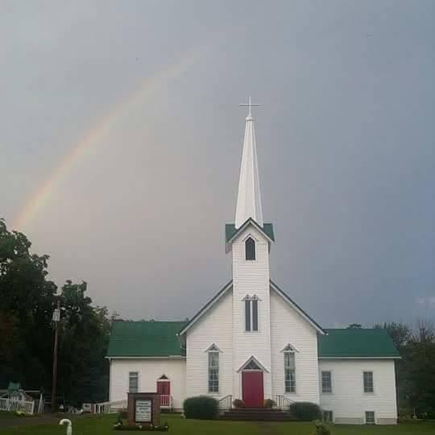
September
2026
Middlefield, OH 44062
440-548-4829
9:00am Sunday school
10:00am Fellowship
10:30am Worship Service
7:00pm Prayer Service
Rev. Will Coley, Pastor
Memory Verse
His divine power has granted to us all things that pertain to life and godliness, through the knowledge of him who called us to his own glory and excellence
2nd Peter 1:3
Westminster Shorter Catechism
Question 35:
What is Sanctification?
Sanctification is the work of God’s free grace, wehreby we are renewed in the whole man after the image of God, and are enabled more and more to die unto sin, and live unto righteousness.
Growing in Grace This Fall
As the leaves begin to turn and the air grows crisp, our church family will be moving into a new section of scripture. This fall, we will be studing the second letter of Peter’s. To prepare ourselves, let’s consider what 2nd Peter chapter 1 is all about.
Divine Power and Percious Promises
Peter opens his letter by grounding us in the sufficiency of God’s grace. He writes that “His divine power has granted to us all things that pertain to life and godliness” (2 Peter 1:3). This is a amazing affirmation of God’s sovereign provision. We do not grow in holiness or even godliness in our own strength; rather, everything we need for godly living flows directly from God’s grace alone.
Central to this passage is the amazing promise that through Christ, we become “partakers of the divine nature” (v. 4). This does not mean we become divine ourselves, but that by the Spirit’s work, we share in God’s own life and character. This is the heart of sanctification: God transforming us into the image of His Son, not by our effort alone, but by His power at work within us.
The Call to Diligent Growth
Peter then issues a stirring exhortation: “Make every effort to supplement your faith with virtue, and virtue with knowledge…” (vv. 5–7). From here he gives us a list of Christian qualities – virtue, knowledge, self-control, steadfastness, godliness, brotherly affection, and love.
While salvation is by grace alone and through faith alone, genuine faith always produces fruit. Peter here calls us to make every effort, which is not a contradiction to grace, but it is a confirmation of the grace bestowed upon us. The Spirit’s indwelling power enables and empowers us in our pursuit of holiness.
Did You Know!
Sproul penned in his commentary concerning 2nd Peter 1:3;
”The most frequent Greek word in the New Testament for “power” is dunamis, from which we get the English word dynamite. The power that God works in our soul to bring us to faith is dynamite. It is an overwhelming power. It is no human potentiality realized by the flesh but, as Peter tells us, a divine and supernatural work of God in the soul. Regeneration is a result of the immediate, supernatural work of God in our soul, a work that only God can bring to pass. If you are a believer in Christ, if you have an inclination toward the things of God, at some point in your life you encountered the touch of the divine in your soul. That inclination did not arise from your bosom. It came from the Spirit of God—divine power through the knowledge of the One who called us—and He called us by His glory, by His majestic power. By His righteous activity He has made us alive.”
God has given His people, through the inspired apostolic Scriptures, everything needed to grow in the true knowledge of Jesus Christ, to discern and resist false teachers, and to live in holy urgency as they await the certain return of the Lord.

We actually work out what God has orked in us, “therefore, my beloved, as you have always obeyed , so now, not only as in my presence but much more in my absense, work out your own salvation with fear and trembling, for it is God who works in you, both to will and to work for His good pleasure” (Philippians 2:12,13). This partnership – God’s sovereignty and our responsibility – is at the core of the faith.
Assurance and the Prophetic Word
Peter concludes the chapter by reminding us that our confidence not in subjective experiences but in the objective truth of Scripture. He reminds us of the Transfiguration, where he personally witnessed Christ’s glory, yet he points us to something even more certain: “the prophetic word” (v. 19).
The prophetic word is vital. Our assurance rests on the reliability of God’s Word, which is “no prophecy of Scripture came about by the prophet’s own interpretation” but was spoken by men “carried along by the Holy Spirit” (vv. 20–21). In an age of shifting truths and false teachers (a major theme in chapter 2), the Scriptures stand as our sure foundation.
As we move into the Fall
My hope this fall is that you are encouraged by the good news of our Lord and Savior and that as we continue to study Peter’s writings, you will be challenged by the Lord. The Lord through Peter calls us to grow in grace, to confirm our calling, and to hold fast to the Lord’s promises.
Let this fall be a season of fruitful growth in the knowledge of our Lord and Savior Christ Jesus.
God Bless
Pastor Will
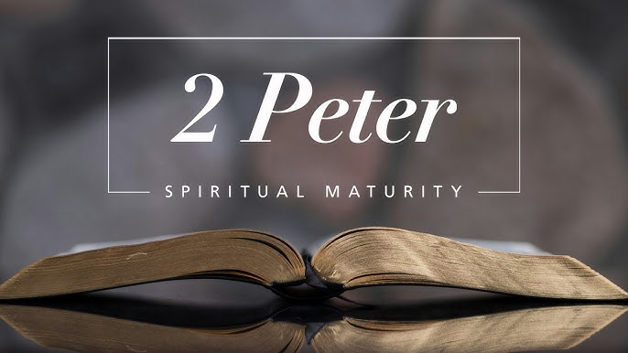


September 1st- Sydney Villalta
September 2nd- Tom & Jan Gotham♥
September 11th- Wyatt Hostetler
September 16th- Alivia Schwendeman
September 16th- Codie & Britani Hart♥
September 17th- Cody & Crystal Kick♥
September 22nd- Tom Gotham
September 25th- Todd & Lawni Ross♥
September 27th- Bobby Sprague Jr
September 28th- Jacob & Sydney Villalta♥

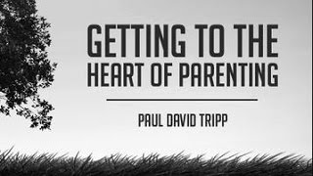

I am planning a parenting conference for this fall.
Signup sheet by the coffee machines.
Dates to be determined once I see how many are interested
It will be a Friday night 6-8:30
and Saturday morning 9 to 1
Sunday
Sermons
9/13 2nd Peter 1:1-2 The Faith obtained
9/20 2nd Peter 1:3-4
His Precious Promises
9/27 2nd Peter 1:5-11
Confirm your calling
10/4 2nd Peter 1:12-21
Never Forget
10/11 2nd Peter 2:1-6
False Prophets and Teachers

MOTTO
Not God’s Plan for my life;
But my life for God’s plan.
Not God’s vision for our church;
But our church for God’s vision.

A sign up sheet is up to see if there is interest in this group for the fall.
We’ve run Grief Share here before it’s just been awhile.
GriefShare is a 13-week Christian support group for those grieving the death of a loved one, offering encouragement, practical guidance, and a safe place to connect with others who understand. Each session includes a video lesson, group discussion, and personal reflection materials to help participants process grief and find hope.
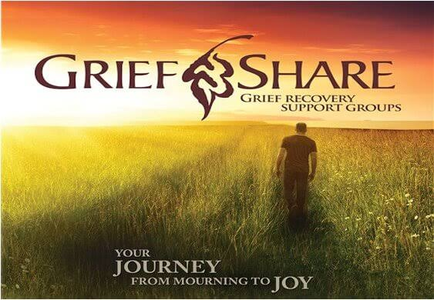

18265 Madison Rd.
Middlefield, Ohio 44062

Phone: 440-548-4829

Email: parkmanchurch@windstream.net

Website: www.parkmanchurch.com

Parkman Church
A Congregation of the Presbyterian Church in America
Presbyterian Church in America
For more information on the PCA check out PCAnet.org
Financial Update
I – Pastor Will – will start adding this in monthly in order to be as transparent as possible when it comes to where we are financially. This will also make it so that we don’t really have to have quarterly financial meetings. If you have any questions feel free to reach out to me.)
Budget information: Year-to-Date (8) months, January – August
Regular Giving $94,103.51 Operating Expenses $112,000 Operating Margin (Regular Giving – Operating Exp.) -$17,896.49
Operating Funds (what’s in the bank) >$1,000.00

Wednesday September 23rd we will need help prepping the food
Thursday September 24th, help needed delivering the food
Signup sheet on the bulletin board.
Fundraising Committee
The next fundraising event will be Swiss Steak Dinner held September 25, 2026 here at Parkman Church. Menu will be Swiss Steak, mashed potatoes, vegetable, salad, drinks, and assorted desserts. Sign up sheets are posted on the bulletin board in the coffee nook. We need volunteers, rolls, and desserts. Pricing for the dinner is:
$20.00 for adults and all carry outs
$10.00 for children ages 6 -10 dine in only
Free for children 5 and under

Pumpkin rolls are coming in October. Dates for making the rolls are Wednesday, October 7th, 14th, and 28th. More information will be coming soon.

November 3rd will be the annual Election Day Turkey Dinner. Please watch for more information coming for volunteers to cook squash and turkeys.

We are looking into possible restaurants in the area that would offer percent of sales night. If you have any suggestions and contacts, please see a committee member.

We are always looking for people to join us and new ideas.

Thank you for your help and support. The committee consists of Brian and Chris Lanstrum, Denise Villers, Pat Johnson, Denise Toth, Todd and Lawni Ross, RC and Casey Mull.
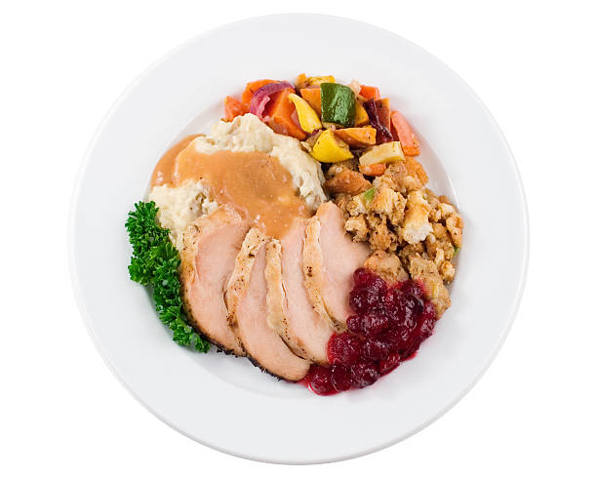
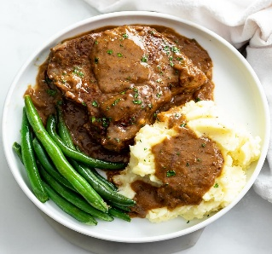


September
 |  |  |  | 2026
Sunday | Monday | Tuesday | Wednesday |  | Thursday | Friday | Saturday
 |  | 1 | 2 |  | 3 | 4 | 5
 |  |  |  |  |  |  | AA, 8:30 pm
6 | 7 | 8 | 9 |  | 10 | 11 | 12
9:00- Sunday School  10:00- Fellowship Time  10:30- Worship Service  7:00- Evening Service | Labor Day |  |  |  |  |  | AA, 8:30 pm
13 | 14 | 15 | 16 |  | 17 | 18 | 19
9:00- Sunday School  10:00 Fellowship Time  10:30- Worship Service  7:00- Evening Service | Elder’s Meeting, 7:00 pm  Women’s Fellowship, 7:00 pm |  |  |  |  |  | AA, 8:30 pm
20 | 21 | 22 | 23 |  | 24 | 25 | 26
9:00- Sunday School  10:00- Fellowship Time  10:30- Worship Service  7:00- Evening Service |  |  | Cardinal Meal Prep, 5:30 pm |  | Cardinal Meal Delivery, 3:45 pm | Swiss Steak Dinner Fundraiser, 5:00-7:00 pm | AA, 8:30 pm
27 | 28 | 29 | 30
9:00- Sunday School  10:00- Fellowship Time  10:30- Worship Service  7:00- Evening Service | Elder’s Meeting, 7:00 pm

October
 |  |  |  | 2026
Sunday | Monday | Tuesday | Wednesday |  | Thursday | Friday | Saturday
 |  |  |  |  | 1 | 2 | 3
 |  |  |  |  |  |  | AA, 8:30 pm
4  Shoe Box Kick-Off | 5 | 6 | 7 |  | 8 | 9 | 10
9:00- Sunday School  10:00- Fellowship Time  10:30- Worship Service  7:00- Evening Service |  |  |  |  |  |  | AA, 8:30 pm
11 | 12 | 13 | 14 |  | 15 | 16 | 17
9:00- Sunday School  10:00- Fellowship Time  10:30- Worship Service  7:00- Evening Service | Elder’s Meeting, 7:00 pm  Women’s Fellowship,  7:00 pm |  |  |  |  |  | AA, 8:30 pm
18 | 19 | 20 | 21 |  | 22 | 23 | 24
9:00- Sunday School  10:00- Fellowship Time  10:30- Worship Service  7:00- Evening Service |  |  | Cardinal Meal Prep, 5:30 pm |  | Cardinal Meal Delivery, 3:45 pm | Craft Show Set-up, 12:00-6:00 pm | Craft Show, 10:00 am- 4:00 pm  AA, 8:30 pm
25 | 26 | 27 | 28 |  | 29 | 30 | 31
9:00- Sunday School  10:00- Fellowship Time  10:30- Worship Service  7:00- Evening Service  Social Hall Reserved | Elder’s Meeting, 7:00 pm |  |  |  |  |  | AA, 8:30 pm

